ENGR 478 Final Report

H.M.R.

Joseph Hernandez
Pedro Moura
Orlean Rallos

Fall 2024
Prof. George Anwar

Table of Contents
1. Introduction & Motivation 2
2. The Smart Greenhouse Project 2
2.1. General-Purpose Input/Output: GPIO 3
2.2. System Tick Timer – Systick 6
2.3. The Interrupt 9
2.4. Analog-to-Digital Converter (ADC) 12
2.5. Sleep Mode 16
3. Challenges 20
4. Future Improvements 21
5. References 22

Introduction & Motivation
In the modern day, efficient and sustainable small-scale gardening is a growing priority often neglected due to busy schedules. It is often difficult for amateur gardeners and small-scale farmers to start and maintain the ideal conditions necessary for quality plant care and efficient resource usage under a general ease of convenience.

As a result, the primary objective of our ENGR 478 Final Project was to develop a Smart Greenhouse prototype device that can provide a way to ensure the optimal soil conditions necessary for small-scale agriculture without constant manual intervention.

Furthermore, the general goal behind developing this prototype device was to demonstrate our general proficiency in developing a microcontroller-based system, highlighting our general understanding and implementation of the core concepts of the ENGR 478 Coursework: the General-Purpose Input/Output (GPIO), the System Tick Timer (Systick) native to ARM Cortex-M4 processor-based microcontrollers, the Interrupt procedure, and the Analog-to-Digital Converter (ADC) module.

The Smart Greenhouse Project
The project goal was to develop a system using the Nucleo-STM32L476RG board, where two analog sensors, one for temperature readings and one for reading the moisture of a plant’s soil, would be read through the ADC of the STM32L476RG. From there, the STM32L476RG would be configured to stay within Sleep Mode while the Systick Timer ran, where the Sleep Mode would be “woken up” by the Systick Interrupt.

This Systick Interrupt would promptly allow the inactive temperature and soil-moisture sensors to activate and poll for a short period. Based on the readings of these sensors’ ADC catalogued outputs, an LED/LCD Panel would update the temperature and soil moisture content, and a Water Pump would activate to increase moisture if found dry by a programmable metric and a Fan would trigger, lowering the temperature of the Greenhouse if certain thresholds were met. This general block diagram can be found in Fig. 1.
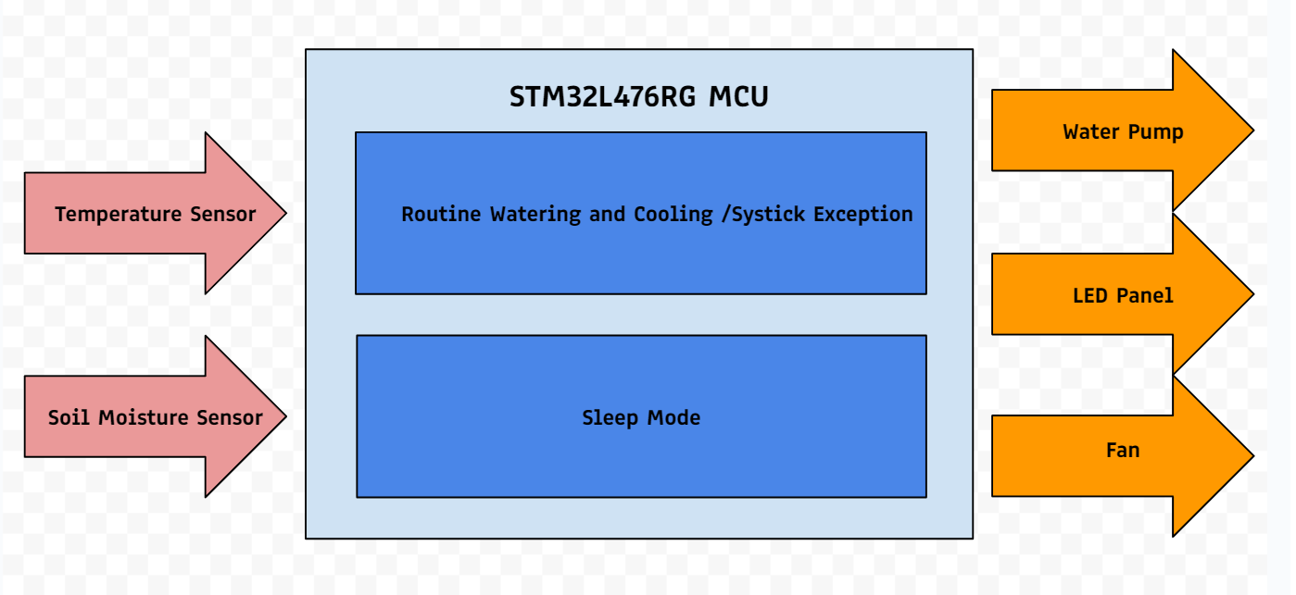
Figure 1: The Smart Greenhouse Block Diagram

General-Purpose Input/Output: GPIO
To incorporate the external devices of the Smart Greenhouse, we first must implement the following GPIO Configurations, as detailed in Table 1., depicting the connections made using the Nucleo-STM32l476RG pins, with Fig. 2. as a general reference.
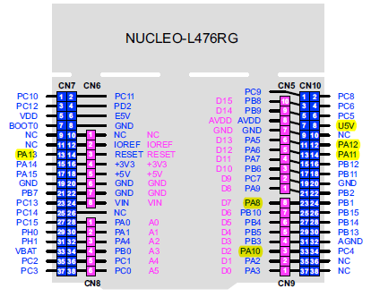
Figure 2: The Nucleo-STM32L476RG Pinout Diagram
Table 1: Nucleo-STM32L476RG GPIO Connections
Nucleo-L476RG Pins | Connections | Notes
+3V3 | VCC for Soil & Temp. Sensors | Supplies 3.3V for both Analog Soil & Temp. Sensors
+5V | VCC for LCD Screen | Supplies 5V for LCD screen
GND | Common Ground for All External Devices | Used common grounds liberally from available pins on ‘L476RG board.
PC0 | ADC3 INPUT from Temp. Sensor | Tempt. Sensor’s Analog Signal outputs to ADC3
PC1 | ADC2 INPUT from Soil Sensor | Soil Sensor’s Analog Signal outputs to ADC2
PB8 | LCD SCL | LCD Serial Clock Line
PB9 | LCD SDA | LCD Serial Data Line
PB1 | LED1 | LED indicating Wet threshold on Soil Sensor
PB13 | LED2 | LED indicating Partially Wet threshold on Soil Sensor
PB14 | LED3 | LED indicating Partially Dry threshold on Soil Sensor
PB15 | LED4 | LED indicating Dry threshold on Soil Sensor
PA5 | N/A | LD2 LED toggles to indicate Timer 16 overflow and subsequent triggered interrupt

Our operational external devices consisted of the Soldered 333098 Capacitive Soil Moisture Sensor, the Texas Instruments LM35ZD Temperature Sensor, and an I2C LCD Screen, displayed in Fig. 2. Below.
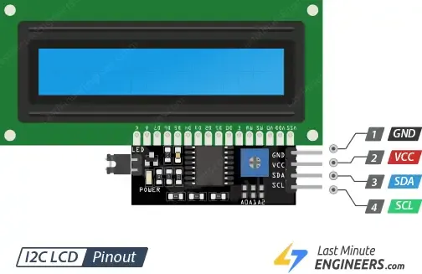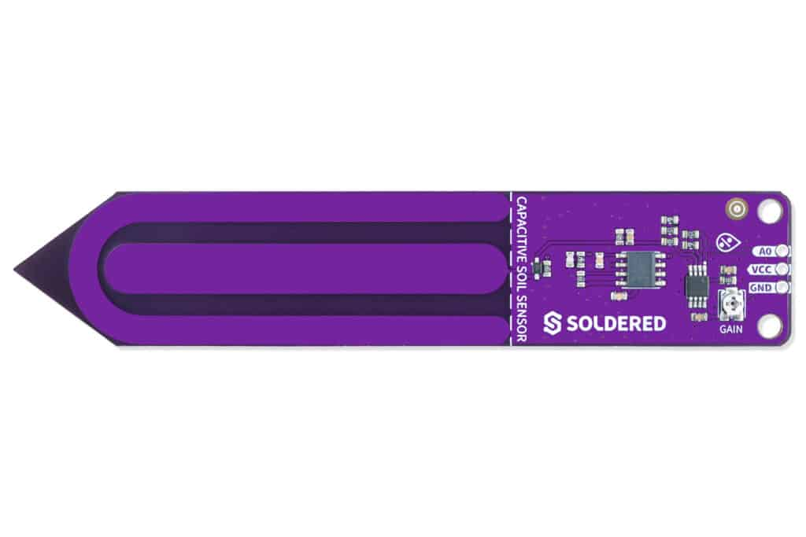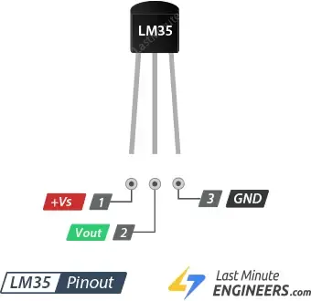
Figure 3: The I2C LCD, 333098 Soil Sensor, & LM35ZD Temperature Sensor

The Soil Sensor and Temperature Sensor has three pins for VCC, Analog Output, and GND, while the I2C LCD screen has four pins for VCC, GND, Serial Data Line (SDA), & Serial Clock Line. Each external device can be outfitted with the appropriate GPIO Pin to ensure proper connection.

The Soil and Temperature Sensors produce an output analog voltage, which can be assigned to an input-mode GPIO Pin associated with ADC3, PC1 & PC0, respectively. In contrast, the I2C LCD screen required two pins, PB9 for the Serial Data Line (SDA) and PB8 for Serial Clock Line (SCL). While the SDA can be bidirectional, for our purposes, the PB9 can be set as an output pin, as it transmits the data to be displayed on the LCD screen with the I2C protocol. Similarly, the SCL can only be unidirectional, so PB8 is also set as an output pin, with the STM32L476RG board acting as the MASTER device and the LCD Screen as the SLAVE device.

System Tick Timer – Systick
For this section, Orlean oversaw incorporating the Systick requirement through developing a timer that would simulate the day cycle of a routine Greenhouse check, where during the timer, the STM32L476RG would be inactive and at timer’s end, the connected external devices would perform the adjustments necessary to maintain the Greenhouse.

Initially, it was proposed that the Systick Timer would act as this day-cycle timer, however upon further research, it became evident that the Systick Timer could not last longer than a minute. Ultimately, the Systick Timer was ill-fitted for the purposes of a large timer, but given it short time span, was decided that it would be best to utilize the Hardware Abstraction Library (HAL) for the purposes of utilizing Systick for smaller delays within our system, such as delays between lines of code.

The particular subfunction within the HAL Library that configures the Systick Timer is the Systick_Config() function, seen below.
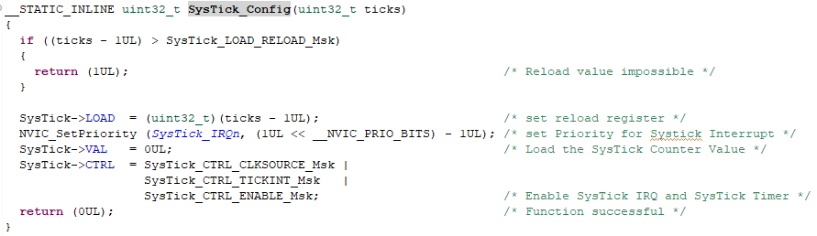
Figure 4: The Systick Configuration Function
This function operates based on a given tick value, which should be equal to or lower than the maximum value for the Reload Register. Given that Systick is a 24-bit counter, the maximum value is $2^{24}-1=16,777,215$. However, based on the HAL configuration, the tick value meets this condition at a tick variable value of 80,000. This configuration permits the Systick to operate the Systick Timer at 1ms intervals. If the tick variable exceeded the maximum value, Systick would return a value of HIGH/”1” indicating an error.

The secondary portion of the Systick configuration function is to configure the timer correctly. The LOAD register can be configured to start its count from the tick variable value. Beyond this, the Systick priority is set to the lowest level through applying the maximum value of the __NVIC_PRIO_BITS mask, as this mask represents the total number of priority bits available and the highest refers to the lowest priority.

The VAL register can be cleared as a value of “0” to configure the timer as a countdown timer. The CTRL register can enable three separate masks to select the clock source as HCLK (80MHz) with the SysTick_CTRL_CLKSOURCE_Msk, enable the Systick Interrupt with the SysTick_CTRL_TICKINT_Msk, and start the Systick timer with the SysTick_CTRL_ENABLE_Msk. Then returning a bit-value of “0” to confirm successful configuration.

This configuration is then adjusted with several HAL Systick-related functions that operates Systick as a time-base of 1ms. This time-base can be used for some time-based HAL functions, independent of other timers, such as the HAL_Delay() function.
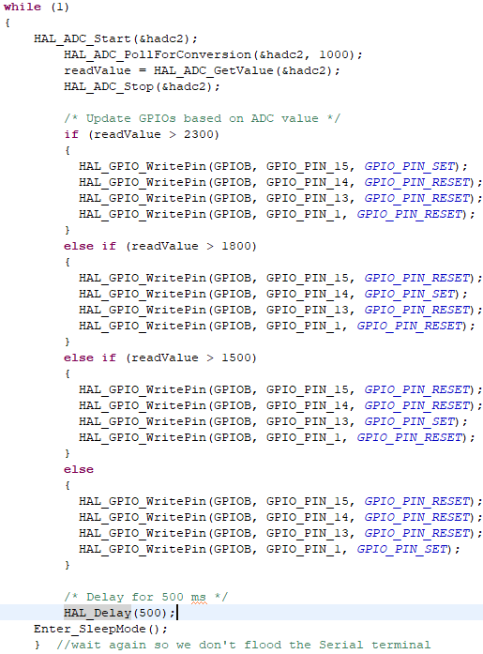
Figure 5: The usage of the Systick HAL_Delay() function to segement functions
For example, in order to segment the operation of certain functions, we can use the HAL_Delay() function to delay for 500ms/0.5s between the boot-up ADC Soil updating lines before activating the Sleep Mode function.

The Interrupt
As stated previously, the Systick Timer proved too quick to properly implement as long timer necessary to simulate a day cycle for the Greenhouse. Instead, an older program from an earlier lab was used to implement Timer 16, as Timer 16 clock frequency could be lowered to extend the timer’s count before overflowing.
Given the HCLK of the STM32L476RG is 80MHz, we can utilize the STM32CubeIDE to interact with the Clock Tree to lower Clock Rate of the APB2ENR Clock used for Timer 16 to 10 MHz.
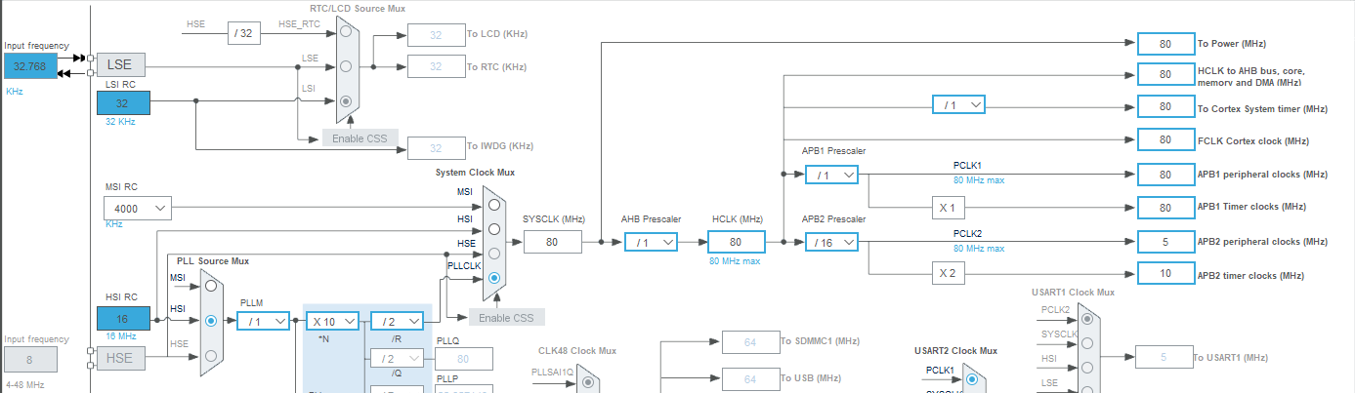
Figure 6: STM32 Clock Tree Configuration

With a reduced clock frequency of 10MHz applied to the APB2 Clock and the 16-bit up-counting Timer 16, we can calculate the following with the goal of getting an overflow time constant of 60 seconds:
$$Prescaler= \frac{f_{HCLCK}×T_{OVERFLOW}}{Counter Max}= \frac{10E6 \left[HZ\right]×60 [sec]}{2^{16}-1}=9155$$

With the Prescaler determined, we can then adjust the Prescaler value to limit Timer 16 to only count to this value, which is equivalent to 60 seconds. However, this will later be slightly altered to incorporate an interrupt that will be triggered once the 60-second Timer 16 overflows. Instead, we can instead, set this Prescaler value as the Counter Period of the AutoReload Register and set the Prescaler to the maximum value of $2^{16}-1=65536$. This ensures that the Timer 16 module can count to its full counting division of 6,5536 but sets the maximum value that the Timer 16 will count to 9,155, or 60 seconds.
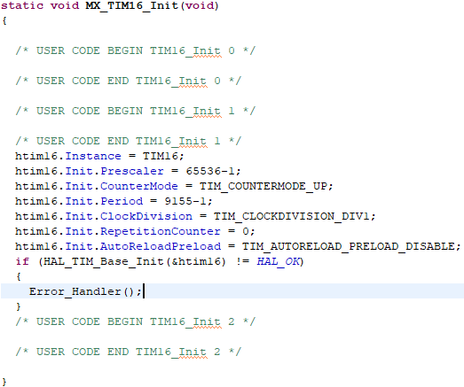
Figure 7: Timer 16 Configuration, with set Prescaler and Counter Period

With Timer 16 properly situated to count up to 1 minute, we can then enable a corresponding interrupt triggered once Timer 16 overflows and establish the function of this interrupt using the Interrupt Handler, HAL_TIM_PeriodElapsedCallBack(). In this function, we set the program to confirm if the interrupt is from Timer 16 and if this condition clears, to toggle the LD2 LED associated with GPIO pin PA5 and perform the ADC-based Temperature Update program.
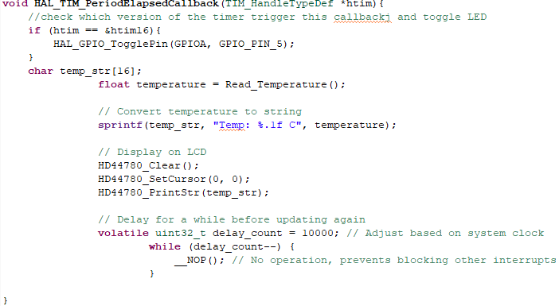
Figure 8: the Timer 16 Interrupt Handler

The LED Toggle within this function is used primarily to indicate when the Timer 16 overflows for the user, denoting a change from the previous state where the timer was busy counting, and for further observation. As can be seen in the Oscilloscope reading, the Timer 16-based Interrupt functions as intended, toggling the PA5 pin at roughly 1 minute with some delay accounted for the interrupt latency delay.
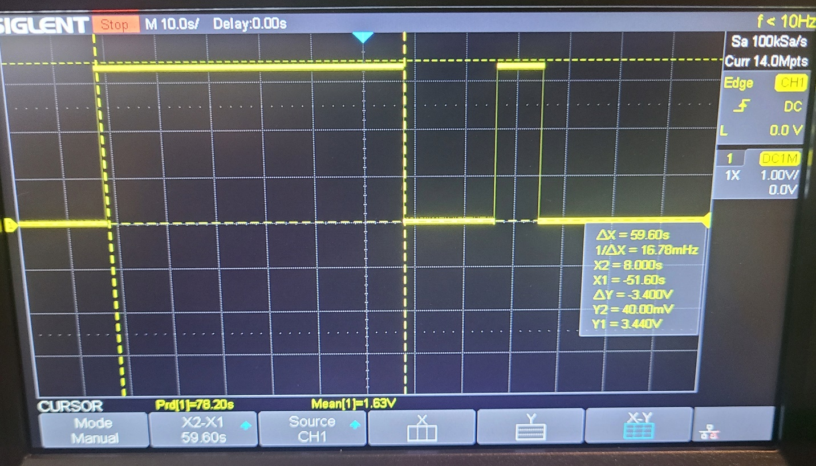
Figure 9: Oscilloscope Confirmation of the Timer 16 Interrupt

Analog-to-Digital Converter (ADC)
For this project, Joseph was the primary lead for initializing and calibrating the ADC for our dual analog sensors: the Texas Instruments LM35ZD temperature sensor and the Soldered 333098 capacitive soil moisture sensor. Initially, Joseph tested both the LM35ZD and the Soldered 333098 sensors individually, ensuring that both worked using the simple ADC lab code individually in the Keil IDE.
Initially, the Texas Instruments LM35ZD was selected as our analog temperature sensor for its capabilities in reading ambient temperature in Celsius around it and output a voltage linearly proportional to this Centigrade Temperature. Furthermore, according to the datasheet, the LM35ZD sensor boasts an average accuracy reading of $±1/4℃$ at standard room temperature and $±3/4℃$ over a temperature range between -55°C to +150°C. The datasheet further states that the LM35ZD sensor retains these accuracy specifications based on the following figure and transfer function.
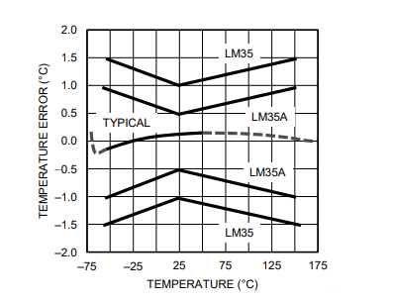
Figure 10: the Temperature Error v. Temperature of the LM35ZD Sensor
$$V_{out}=10\frac{mV}{℃} ×T;V_{out} is the LM35 output voltage, T is temperature in ℃$$
Similarly, the Soldered 333098 was selected as the analog soil moisture sensor for its robust stability under a variety of conditions, starting with its capacitive nature. While other soil moisture sensors are resistive, a capacitive sensor operates measuring soil capacitance while remaining durable and low corrosive with no exposed electrodes for long-term usage. In tandem with our temperature sensor, the 333098 sensor consistently requires low power consumption as demonstrated by its low, but linear nature between the supply current and temperature over a temperature range of -50 °C to 125 °C.
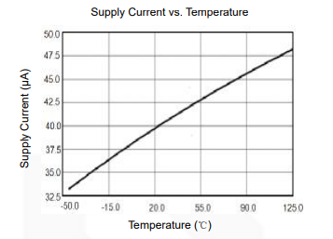
Figure 11: The Supply Current v. Temeprature of the Soldered 333098 Soil Sensor
Once established, the code integrates two ADCs with an I2C interface for a real-time temperature monitor display. The ADC3 was configured to interface with the LM35ZD Temperature Sensor, operating in the single-ended mode, to ensure accurate voltage measurements without requiring differential signals. The 12-bit resolution provides a maximum value of 4096 discrete levels, providing a precise conversion range of the sensor’s analog output to digital. We can see this in the Read_Temperature() function, which handles the process using the HAL_ADC_Start() function, polling for competition using the HAL_ADC_PollForConversion(), and retrieving the raw digital value with HAL_ADC_GetValue(). The temperature can be further encoded using the following formula:
$$T \left[℃\right]= \frac{ADC ×3300}{2^{12}×10}$$
The ADC value is retrieved from the HAL_ADC _GetValue, using a reference voltage constant of 3300mV from the Sensor’s VCC supply of 3.3V, $2^{12}=4096$ as the ADC resolution, and 10 mV/°C as the sensor’s output scale factor.
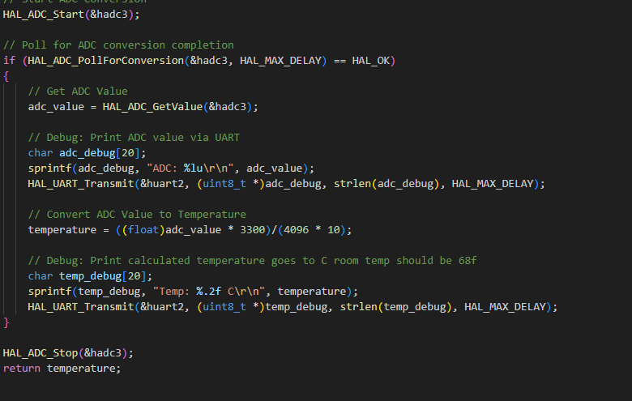
Figure 12: The ADC Conversion Protocol
For debugging, the raw ADC value and calculated temperature are transmitted via UART, providing insights into real-time data acquisition. Another way to debug this is using the DR register which gives us the hexadecimal of the voltage output of the Temp. Sensor. These are then sent to the LCD via the command set up for us in the library file, which denotes the address and sends the bits to the LCD screen.
Meanwhile, the ADC2 is configured in a continuous conversion mode to handle the other analog input generated from the 333098 Soil Moisture Sensor. It, similarly, operates with the same 12-bit resolution and updates the GPIO ouputs of PB1/13/14/15, based on predefined thresholds to provide visual feedback on the sensor’s states, with PB1 acting as a “Full Wet” LED, and PB15 as the “Full Dry” LED indicator.
However, As the ADC3 for the Temp. Sensor operates with the Initialized End-of-Conversation that permits the program to update the temperature based on the Timer 16 interrupt. Consequently, we permit ADC2 to update without being enclosed with the Timer 16 interrupt, disabling the End-of-Conversation Selection, as seen in the figures below.
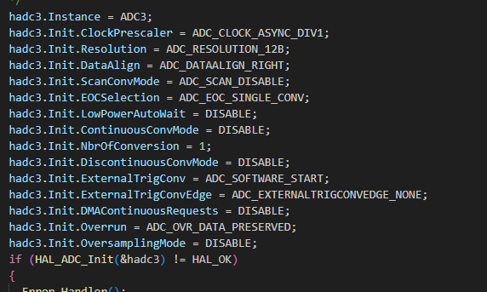
Figure 13: The ADC3 Configuration
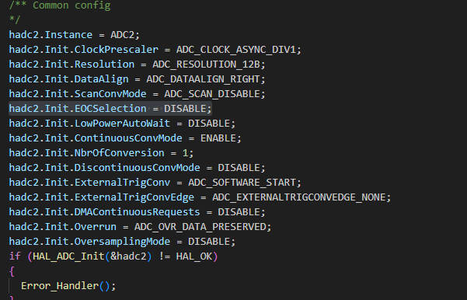
Figure 14: The ADC2 Configuration
Another specific detail about the ADCs, was that to ensure optimal performance by aligning the peripheral clock frequency set by the Timer 16 configuration, the ADC Prescalers are set to the mask ADC_CLOCK_ASYNC_DIV1, ensuring optimal performance by aligning the ADCs’ sampling speeds.
Concerning the I2C1 Peripheral necessary to configure communication with the LCD, we can implement the LiquidCrystal_I2C library to simplify the initialization and operation of the display. Using a 7-bit addressing mode and optimizing the time setting, the I2C interface facilitates an efficient data transfer to the LCD, which periodicially updates with the Timer 16 interrupt. In the Timer 16 interrupt, the Read_Temperature() function is called to retrieve the latest sensor data, which is formatted as a string and set to the LCD for display using the HD44780_PrintStr() function.
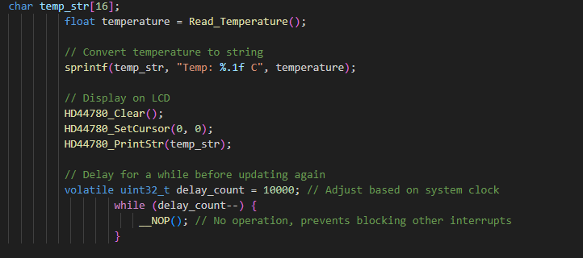
Figure 15: The LCD Display Protocol

Sleep Mode
Pedro’s role in this project was researching how to implement Sleep Mode function for the program, while Orlean translated this knowledge into code using the HAL Library. The STM32L476RG is outfitted with several low-power modes that can be implemented to reduce power consumption while keeping certain functions active, depending on the chosen low-power mode. Our team decided to work with a Sleep Mode configuration, as that would disable the CPU clock stopping the CPU from completing further instructions, while keeping certain peripherals and related clocks active, with the caveat that an interrupt and/or event can resume normal operation.

Concerning our initial project goals, this low-power consumption made the implementation of Sleep Mode an attractive addition to our main program. According to the RM0351 STM32L4xxx Reference Manual, Sleep Mode can hence be entered while the SLEEPDEEP bit is set to LOW/”0” and no interrupt or event is pending, as displayed in Table 2. Below.

Table 2: Sleep Mode Entry & Exit
Sleep-now Mode | Description
Mode entry | WFI (Wait for Interrupt) or WFE (Wait for Event) while:  - SLEEPDEEP = 0  - No interrupt (for WFI) or event (for WFE) is pending
On return from ISR while:
- SLEEPDEEP = 0 and
- SLEEPONEXIT = 1
- No interrupt pending
Mode exit | If WFI or return from ISR was used for entry  If WFE was used for entry and SEVONPEND = 0  If WFE was used for entry and SEVONPEND = 1
Wakeup latency | None

Given this, we can then configure a Sleep Mode Function, in which we set the appropriate registers in which the SLEEPDEEP bit can be set to LOW/”0” This can be seen in the figure below, which details the configuration necessary for implementing Sleep Mode, using the HAL Library.
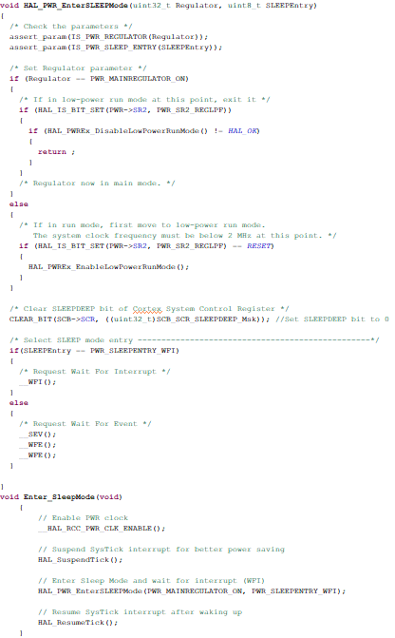
Figure 16: The Sleep Mode Configuration and Initialization

From here, we can implement this configuration function for Sleep Mode within our main program, within the infinite loop. This will set the STM32L476RG microcontroller in Sleep Mode.
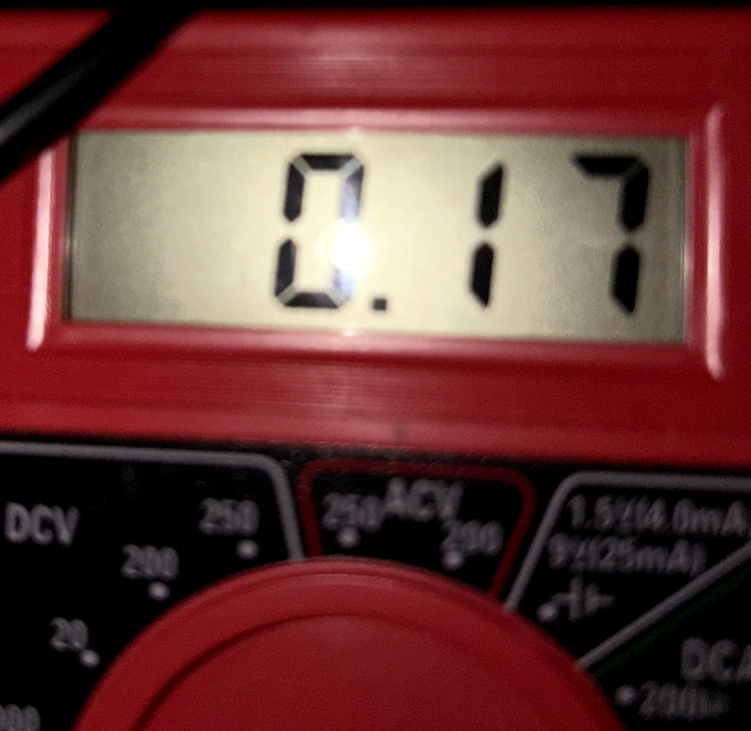
Figure 17: The Sleep Mode Current Reading

While this was not demonstrated during the demonstration, this setting was tested through a multimeter, in which current can be observed through the Nucleo-STM32L476RG’s JP6/IDD pins. When set in Sleep Mode, the current reading of 0.17mA/170µA. According to the STM32L4xx Datasheet, this is in-line with general Current consumption characteristics of the Sleep Mode.
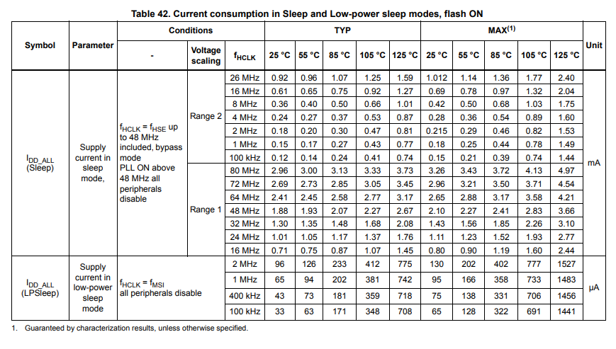
Figure 18: Sleep Mode Current Consumption

Challenges
During the project, there were several challenges that resulted in our prototype device falling short of our initial goal focus, that centered primarily around combining the separated C programs like the ADC and the Interrupt to sync together correctly.

For example, when we configured the Smart Greenhouse to wait for a Timer16-based interrupt to occur before updating the temperature reading on the LCD screen, we would place the LM35ZD-ADC3 code with the instructions to update the LCD screen of the current temperature within the ElapsedCallback function associated with the Timer 16 1-minute Timer Interrupt. However, when we attempted to further update the Timer 16 interrupt code by similarly adding the working 333098 Soil Moisture Sensor Update Code in the ElapsedCallback function/Timer 16 Interrupt Handler, we would run into an error where the entire system would be rendered effectively inert and all expected programs would fail to trigger, from the 1-minute timer to the updating temperature reading.

As a result, we decided to implement the 333098 Soil Moisture Sensor Code within the main program’s infinite loop, which made the Sleep Mode configuration effectively nonfunctioning. Instead, at the start of the microcontroller boot-up, the soil moisture sensor would function once, before starting the timer-interrupt, never updating again until the next bootup of the microcontroller. We had felt that the inclusion of the Soil Moisture update was more important to the centralized theme of the Smart Greenhouse project and that the configuration of Sleep Mode was secondary to this inclusion. Unlike the temperature sensor, the soil sensor required active polling, which is why two separate ADCs were used. Due to the active conversion hadn't been enabled, this resulted in the issue of it not polling on the temperature sensor. Thus, our best option to get around this issue was to include ADC2. Despite working, it then presented us with the issue of only functioning upon startup because it was improperly out of sync with the rest of the code.

Beyond this, we ultimately ran into issues with the sensitivity behind the Soldered 333098 Soil Moisture Sensor that resulted in a general reading between moisture and output voltage. However, this general reading would fluctuate wildly when applied with the 12-bit ADC, resulting in accurate but unprecise readings. This was further disastrous with our initial plans to implement the Soil Moisture Sensor’s ADC readings into the LCD screen, alongside the working temperature readings on said screen, as this fluctuation would cause the LCD screen to flick on-and-off, due to faulty readings causing a numeric overload.

Finally, while our team worked on implementing the core requirements of this code, we routinely had difficulty implementing the external device modules: the temperature-triggered fan and the soil moisture-triggered water pump. When testing with just these devices, we would get some results by pulsing connected GPIO pins with operating voltages between 0V, 3.3V, and 5V. However, when these devices were supplied with the approved power based on their datasheets, they would activate momentarily before shutting off. Given our issues with debugging our other portions of the code, we ultimately decided that the external devices were of lower priority to the completion of our project.

Future Improvements
Given the opportunity to further refine our project, there are several fields that could be reworked and better implemented that would have aligned closer to our initial project goal and focus.

Addressing one major concern stated, if permitted more time, our team would allocate more focus on syncing our respective programs together to better function based on our initial design. For example, Orlean and Joseph were able to configure Orlean’s Timer-based interrupt with Joseph’s ADC temperature updating program, by incorporating the LM35ZD to update within the Interrupt ElapsedCallback function, once the 1-minute Timer16 interrupt occurred. However, the program would be updated to further incorporate the ADC soil-moisture updating program. This would take more time to further understand why the ADC soil-moisture updating program could not function within the parameters of a timer-based Interrupt. Our initial suspicions lie that some ADC2-ADC3 configuration incompatibilities may have resulted with priorities getting entangled and soft locking the program.

Concerning the soil moisture sensor altogether, an alternative soil moisture sensor could have been chosen all together, after our evaluation over how fickle the Soldered 333098 sensor was. In hindsight, we could have purchased several other sensors, both capacitive and resistive, and tested their precision in producing consistent results.

Beyond just an alternative soil moisture sensor, we would have more time to incorporate the Temperature-triggered fan and the Moisture-triggered Water Pump. As we have seen with our program, the Temperature-ADC code works well and could be used to smoothly integrate a reactionary fan, which would activate when the temperature rises above a certain Celsius threshold. Likewise, a more stable Soil sensor could provide more accurate and consistent readings that can trigger a water pump rather than illuminating indicator LEDs.

However, on a broader scale, one thing that our project team would incorporate more of was more face-to-face time working on the project together. While we communicated to one another about how our respective project domains were going, we would only come together through online communication, resulting in segmented programs. However, this also resulted in calibration issues with the hardware. For example, Orlean had bought the living plant, but since Joseph was working on the ADC configuration of the soil moisture sensor, the plant was not used as much as it should have been during ADC calibration. Furthermore, this made co-debugging difficult through online communication. Ultimately, Orlean was able to assist Joseph in debugging issues, however this took longer than our team would have liked, as certain ideas were difficult to express and made debugging longer than it should have been, in hindsight.

References
ARK4579More. “STM32F103 Nucleo: LM35 Temprature Sensor (UsingMbed.h).”Instructables, www.instructables.com/STM32F103-Nucleo-LM35-Temprature-Sensor-using-Mbed/.

“Capacitive Soil Sensor - Soldered Electronics.” Soldered Electronics, 30 Nov. 2024, soldered.com/product/capacitive-soil-sensor/. Accessed 22 Dec. 2024.

Digi-Key. “Getting Started with STM32 and Nucleo Part 6: Timers and Timer Interrupts | Digi Key Electronics.” YouTube, 17 Aug. 2020, www.youtube.com/watch?v=VfbW6nfG4kw.

Electrofun. “STM32 Nucleo - Single Mode ADC | LM35 Temperature Sensor | ADC Resolution.” YouTube, 12 Aug. 2020, www.youtube.com/watch?v=uSBs1iJntoA. Accessed 22 Dec. 2024.

FedorChervyakov. “GitHub - FedorChervyakov/Stm32-Lm35: Read Analog Voltage Output of LM35, Convert to Temperature, and Print the Temperature to UART. Uses DMA for ADC and UART Tx.” GitHub, 2019, github.com/FedorChervyakov/stm32-lm35. Accessed 22 Dec. 2024.

Magdy, Khaled. “STM32 LCD 16x2 Tutorial & Library | Alphanumeric LCD 16x2 Interfacing.” DeepBlue, 24 June 2020, deepbluembedded.com/stm32-lcd-16x2-tutorial-library alphanumeric-lcd-16x2-interfacing/.

STM32. RM0351 Reference Manual STM32L47xxx, STM32L48xxx, STM32L49xxx and STM32L4Axxx Advanced Arm ® -Based 32-Bit MCUs. 2021.

STMetaTronics. “LM35 Sensor Interface | How to Interface Temperature Sensor with Stm32 Controller | STM Tutorials.” YouTube, 26 Sept. 2021, www.youtube.com/watch?v=ssueh8dOoy0. Accessed 22 Dec. 2024.

Texas Instruments. LM35 LM35 Precision Centigrade Temperature Sensors Calibrated Directly in Celsius (Centigrade) • Linear + 10-MV/°c Scale Factor • 0.5°c Ensured Accuracy (at 25°C) • Rated for Full −55°c to 150°c Range • Suitable for Remote Applications • Low Cost due to Wafer-Level Trimming • Operates from 4 v to 30 v • Less than 60-ΜA Current Drain • Low Self-Heating, 0.08°c in Still Air • Non-Linearity Only ±¼°c Typical • Low-Impedance Output, 0.1 Ω for 1-MA Load 2 Applications • Power Supplies • Battery Management • HVAC • Appliances 3 Description. Dec. 2017.

